In this implementation project, I have use logistic regression and PLA for linear classification, Gaussian Process and logistic regression after PCA to classify the data.

Logistic regression is a very common algorithm for linear classification. It uses a sigmoid activation function and then use gradient descent to minimize the loss function. In my project, it has an average accuracy about 95%.

In [probability theory](https://en.wikipedia.org/wiki/Probability_theory) and [statistics](https://en.wikipedia.org/wiki/Statistics), a Gaussian process is a [stochastic process](https://en.wikipedia.org/wiki/Stochastic_process) (a collection of random variables indexed by time or space), such that every finite collection of those random variables has a [multivariate normal distribution](https://en.wikipedia.org/wiki/Multivariate_normal_distribution), i.e. every finite [linear combination](https://en.wikipedia.org/wiki/Linear_combination) of them is normally distributed. The distribution of a Gaussian process is the [joint distribution](https://en.wikipedia.org/wiki/Joint_distribution) of all those (infinitely many) random variables, and as such, it is a distribution over functions with a continuous domain, e.g. time or space. In the Gaussian process classifier, I use a rbf kernel with r = 1 to implement GPC. I got about 74% accuracy.

The last one I use is logistic regression after PCA. Principle component analysis (PCA) is one such method.

• This is a powerful, popular and perhaps the simplest dimensionality reduction method that has various applications. It can also be viewed as a feature selection method, but not in a conventional way.

• Two main ideas are behind PCA: – Adjust (linearly) the view point so that the direction of the major variance becomes one of the coordinate. – Or, PCs are the coordinates along which the data vary the most. – Compress the data by taking fewer coordinates. Pros: less data to store or transmit. Cons: los of information. – The second idea can also be considered as feature selection in the transformed space

I left 80% of the information which decrease the dimension from 31 to 4. After that. I use logistic regression to do the classification. I get 96.8% accuracy which is the best in all implementation project.

To compare all the algorithm, I use wilcoxon’s signed-rank test to choose which is the best. I run the three algorithms on the same partition using 10 fold cross validation. I will list the 10 fold cross validation accuracy as follows.

Logistic regression:

[0.8771929824561403,

0.9473684210526315,

0.9473684210526315,

0.9649122807017544,

0.9649122807017544,

0.9473684210526315,

0.9824561403508771,

0.9649122807017544,

0.9473684210526315,

0.9636363636363636]

Gaussian Process:

[0.45614035087719296,

0.7894736842105263,

0.7192982456140351,

0.6491228070175439,

0.6666666666666666,

0.8771929824561403,

0.7543859649122807,

0.8421052631578947,

0.7894736842105263,

0.8545454545454545]

Logistic regression after PCA:

[0.9473684210526315,

0.9473684210526315,

0.9473684210526315,

0.9824561403508771,

0.9473684210526315,

0.9824561403508771,

1.0,

0.9824561403508771,

0.9824561403508771,

0.9636363636363636]

Test 1

H0: logistic regression H1: Gaussian Process

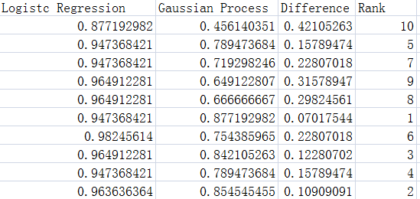

We can see that Twilcox = 55 > V . I will choose logistic regression.

Test 2

H0: logistic regression with PCA H1: Gaussian Process

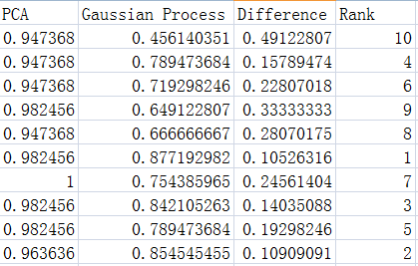

We can see that Twilcox = 55 > V. I will choose logistic regression After PCA.

Test 3

H0: Logistic regression H1: logistic regression with PCA

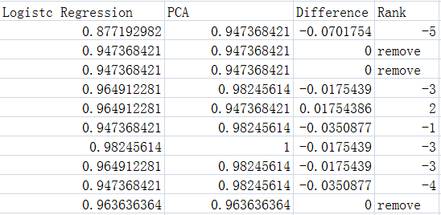

W12 = 2, W21 = 18. Twilcox = 2 < 8. We reject logistic regression and choose PCA